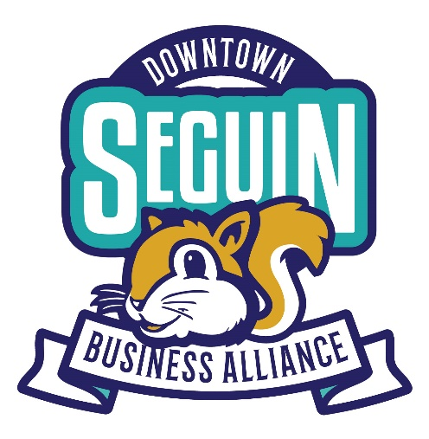

Downtown Business Alliance of Seguin Enrollment
Hello! Welcome to the Downtown Business Alliance of Seguin (DBA). This organization was created by a group of business owners in Seguin and the surrounding area who recognize that a commitment to showcases our historic downtown, vibrant business, and entertainment is key to growth and success for us all and our thriving community!
We are here as a resource for you. Our mission is to promote and maintain a thriving Downtown. We do that by producing great events that bring people downtown, marketing downtown as an exciting, desired destination, and managing downtown maintenance programs that keep our downtown clean, safe and attractive.

Membership Enrollment Form

Company Name:
Primary Contact:
Business Address:
Mailing Address:
Business Phone:
Email Address:

Membership Dues
- Business Membership $125 – This membership covers 1 business entity and includes a listing on the website.
- Friend of the DBA of Seguin $75 (Individuals, non-profit organizations)
Mail or deliver checks to DBA Treasurer Bob Pickett at 110 N. Austin St., Seguin TX 78155 or call (830) 379-0730 to pay over the phone.

Website Directory and Membership Category
- Antiques/Home Décor □ B&B/Hotel □ Retail □ Children/Education
- Dining/Entertainment □ Insurance □ Non-Profit Org. □ Professional Services
- Salon/Health and Wellness □ Event Venue □ Real Estate □ Financial Services

Your business will be listed on the DBA of Seguin website under a membership directory which will show your address, phone number, and will feature a link to your website. Please provide your website address for membership and promotions on your website.
Website Address _____________________________________________________

Note: Your logo will be uploaded to our website and will be the reference for your company in our directory. It is the business owner’s responsibility to ensure the DBA of Seguin has the most recent and accurate logo for your business.
⃝ I authorize the DBA of Seguin to share my contact information on the organization’s website and directory thatis public. (Note: Your information will not be shared or sold for solicitation purposes.)

Welcome aboard! You are now a member of DBA. What are your next steps?

Committee Involvement
You are one step closer to being involved and supporting our growing Seguin Downtown. We would love to have you serve on one of our committees. Which of the following are you interested in supporting?
- Right now, I would love to help with a committee, and I am willing to lend my talents and help with a specific area of the organization. (Select all that apply at the bottom of this page)
- As of today, my schedule only allows me to commit to attending events and supporting events as time permits.

Committees
If you are ready to get moving and help our organization grow, here is a list of the current committees you can join: Ongoing Committees
- Membership Services & Retention □ Cocoa Sip n Stroll & Holiday Stroll in Central Park
- Marketing - includes Third Thursday promotions / Shop Local Year-Long Campaign / General Downtown Marketing

Benefits of your Membership
  - Collective advertising Opportunity to participate in select DBA advertising
  - Ability to submit your events for posting to the Official DBA Calendar
  - Ability to submit your events/notices for DBA Email campaigns
  - Opportunity to participate in the downtown ‘We’re Open’ banner program
  - Third Thursday promotions
  - Ability to belong to a collaborative network of business owners to promote the success of downtown with other local entities (Seguin Chamber, City of Seguin, Guadalupe Country, etc.)
  - Partnership with the Main Street Office
  - More benefits to come as we grow . . .

Internal Use: Join Date Amount Paid ☐ Check ☐ Square ☐ Cash

Paid Date Receipt Sent

